Objective Questions

- List the different dtypes of columns in table “ball_by_ball” (using information schema)
Query :
desc ball_by_ball;
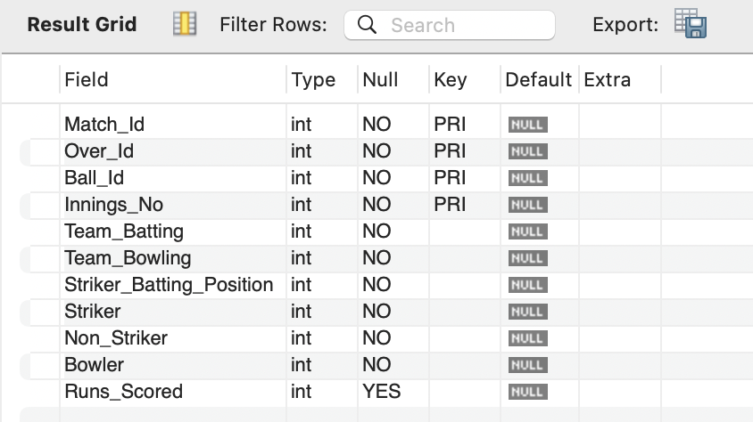
Explanation: Used desc command to retrieve table schema
- What is the total number of runs scored in 1st season by RCB (bonus: also include the extra runs using the extra runs table)

Query :
select sum(coalesce(r.extra_runs,0) + coalesce(b.runs_scored,0)) as total_runs
from ball_by_ball b
join Team t
on b.Team_Batting=t.Team_id
join Matches m
on b.Match_id= m.Match_id
left join Extra_Runs r
on b.Match_id = r.Match_id
and b.Innings_No=r.Innings_No
and b.Ball_Id =r.Ball_Id
and b.Over_Id = r.Over_id
where lower(t.Team_Name) in ('rcb', 'Royal Challengers Bengaluru', 'Royal Challengers Bangalore')
and m.Season_Id=(select min(season_id) from matches)
group by t.team_name;

Output: 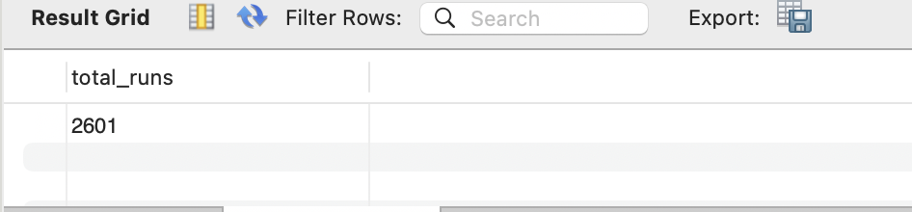
Explanation:
- Used joins to merge tables (ball_by_ball, matches and extra runs)
- Handled missing value with coalesce
- Filtered the team with where clause
- Summed the total runs using sum() and grouped by team name to get the total runs

- How many players were more than the age of 25 during season 2014?
Query : select count(*) as age_above_25
from Player
where ('2014'- year(DOB)) >25;

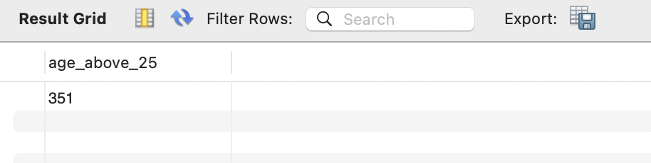
Explanation:
- Where clause is used to filter the age above 25 from player table
- Count () to count the players of age greater than 25

- How many matches did RCB win in 2013?
Query :
select count(*) as rcb_win
from Matches
where year(Match_Date) ='2013' and Match_Winner in (select Team_id from Team where Team_Name in ('rcb', 'Royal Challengers Bengaluru', 'Royal Challengers Bangalore'));
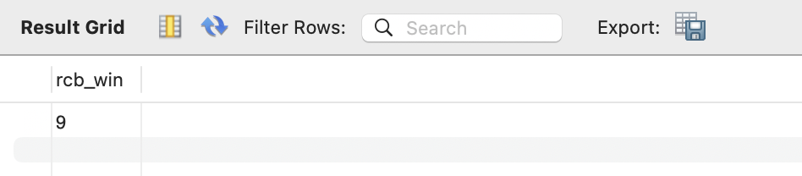
Explanation:
- Where clause is used to filter match year using year() and team won the match
- Subquery is used to retrieve the team id
- count () is used to count the matches that won by rcb

- List the top 10 players according to their strike rate in the last 4 seasons
Query :
select p.player_name, sum(b.runs_scored) as total_runs
from ball_by_ball b
join player p
on b.striker = p.player_id
group by b.striker
order by total_runs desc
limit 10;
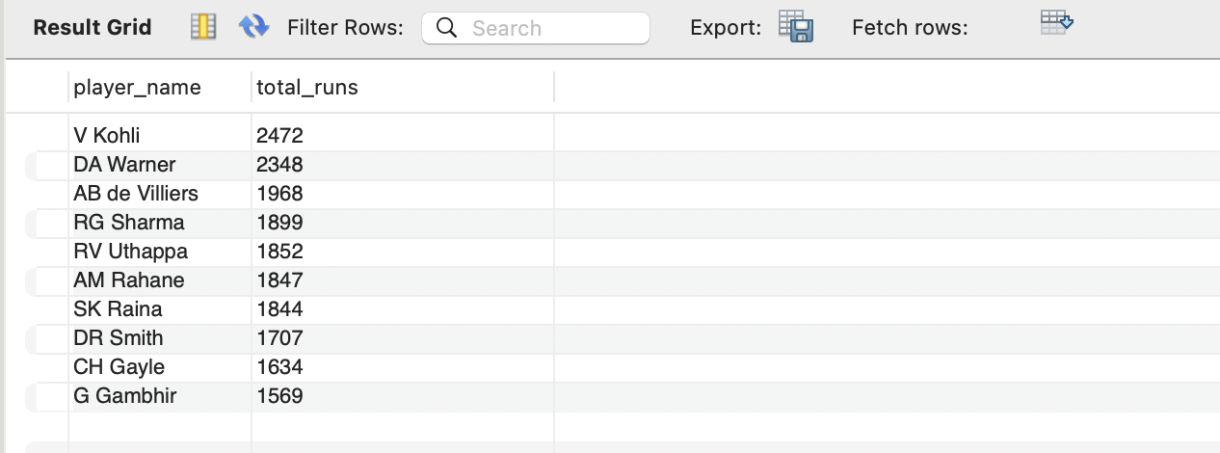
Explanation:
- Used joins to merge the bal_by_ball table and player table
- Grouped by striker and found total runs using sum()
- Order the column descending order
- Used limit to get the top 10 players according to the highest total runs
- What are the average runs scored by each batsman considering all the seasons?
Query :
select striker, avg(Runs_Scored) as avg_runs
from ball_by_ball
where striker is not null
group by striker;
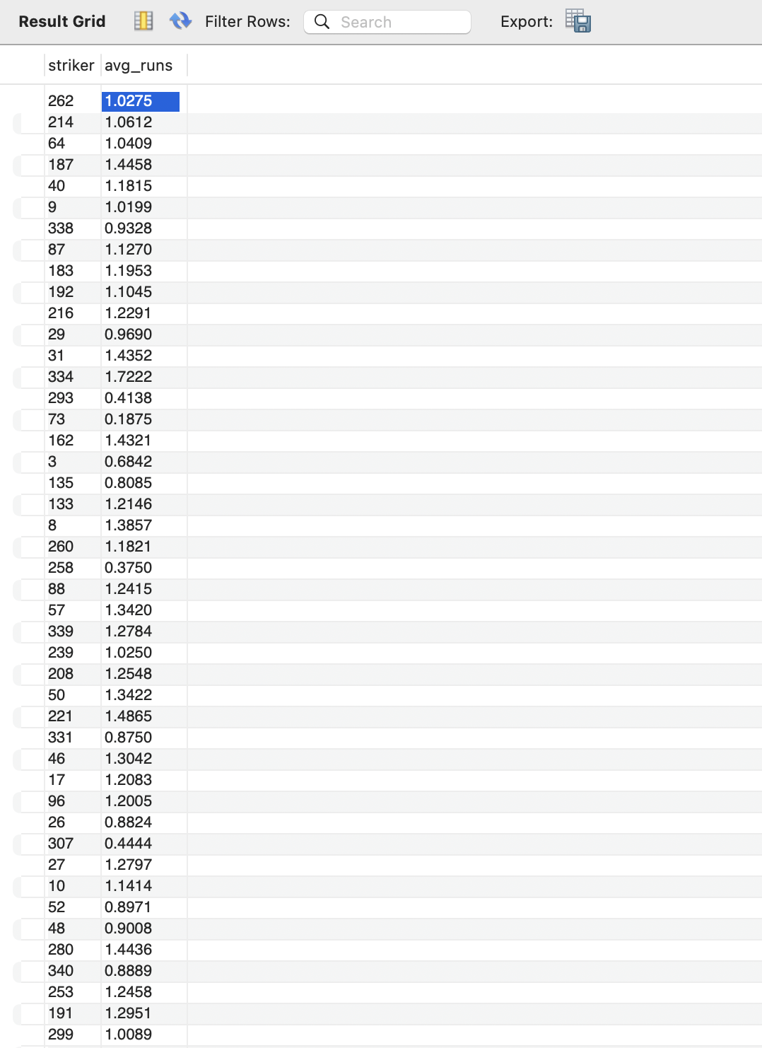
Explanation:
- Used columns striker and avg(Runs_Scored) to calculate the average runs scored per ball faced
- Filtered data using where striker is not null to remove rows with missing player names
- Found average value by grouping the strikers

- What are the average wickets taken by each bowler considering all the seasons?
Query :
with wkt_cnt as (select fielders, count(player_out) as wicket_count
from Wicket_Taken
where fielders is not null
group by fielders)
select fielders as bowler, wicket_count/(select sum(wicket_count) from wkt_cnt) as average_wickets
from wkt_cnt;
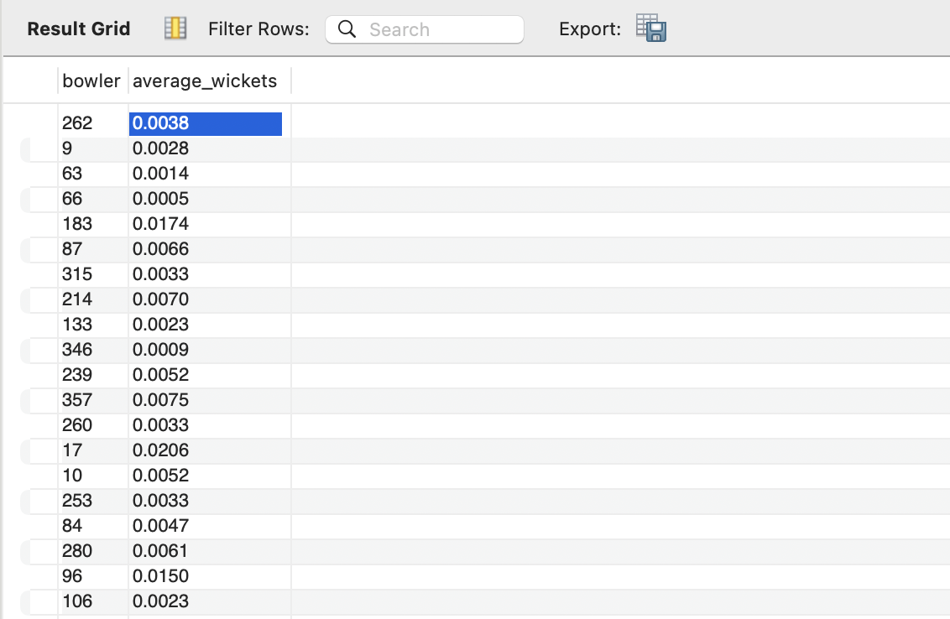
Explanation:
- Used a Common Table Expression (CTE) named wkt_cnt to find the total wickets count of bowler
- Filtered data using where fielders is not null to remove the fielder was involved
- Grouped by fielders and counted player_out to get individual wicket totals
- Selected columns fielders (renamed as bowler) and calculated the percentage of wickets of bowler
- Used a subquery (select sum(wicket_count) from wkt_cnt) to find some of wickets

- List all the players who have average runs scored greater than the overall average and who have taken wickets greater than the overall average
Query :
with player_batting as(select b.striker as player_id,
sum(coalesce(b.runs_scored, 0)) as total_runs,
count(distinct b.match_id) as matches_played,
sum(coalesce(b.runs_scored, 0)) * 1.0 / count(distinct b.match_id) as avg_runs
from ball_by_ball b
group by b.striker),

player_bowling as (select b.bowler as player_id,
count(w.player_out) as total_wickets
from ball_by_ball b
left join wicket_taken w
on b.match_id = w.match_id
and b.innings_no = w.innings_no
and b.over_id = w.over_id
and b.ball_id = w.ball_id
and w.kind_out not in (3, 5, 9)
group by b.bowler),

overall_metrics as (select (select avg(avg_runs) from player_batting) as global_avg_runs,
(select avg(total_wickets) from player_bowling) as global_avg_wickets)

select p.player_name,
round(bat.avg_runs, 2) as player_avg_runs,
round(om.global_avg_runs, 2) as benchmark_avg_runs,
bowl.total_wickets as player_total_wickets,
round(om.global_avg_wickets, 2) as benchmark_wickets
from player_batting bat
join player_bowling bowl on bat.player_id = bowl.player_id
join player p on bat.player_id = p.player_id
cross join overall_metrics om
where bat.avg_runs > om.global_avg_runs
and bowl.total_wickets > om.global_avg_wickets
order by bat.avg_runs desc, bowl.total_wickets desc;
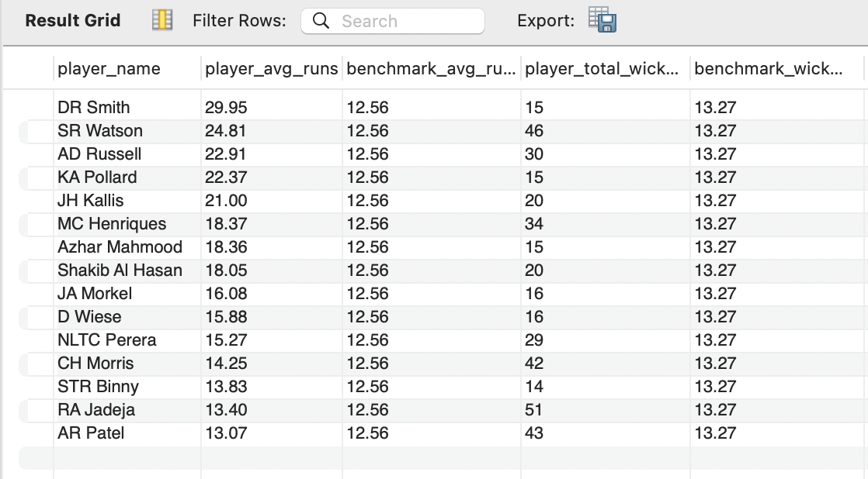
Explanation:
- Used three Common Table Expressions (CTEs) player_batting, player_bowling, and overall_metrics to separate batting, bowling, and global calculations
- Aggregated batting data in player_batting by grouping by b.striker to find total_runs, matches_played, and the average runs scored per match
- Aggregated bowling data in player_bowling by grouping by b.bowler and used a LEFT JOIN with wicket_taken to count total wickets while filtering out non-bowler wickets using kind_out not in (3, 5, 9)
- Calculated global benchmarks in overall_metrics by finding the average of runs and wickets across all players in the database
- Merged all tables using JOIN t
- Filtered for all-rounders using a WHERE clause to filter players whose individual batting averages and total wickets are higher than the global averages
- Rounded to two decimal places, sorted in descending order to prioritise the top-performing batsmen and bowlers

- Create a table rcb_record table that shows the wins and losses of RCB in an individual venue.
Query :
create table rcb_record as
select v.venue_name,t.team_name,
case
when m.match_winner = 2 then 'win'
when m.outcome_type =1 then 'no_result/tie'
else 'loss'
end as match_result
from Matches m
join venue v
on m.venue_id = v.venue_id
join team t
on m.match_winner = t.team_id
left join win_by w
on m.win_type = w.win_id
where team_1 =2 or team_2=2
order by venue_name;

select * from rcb_record;
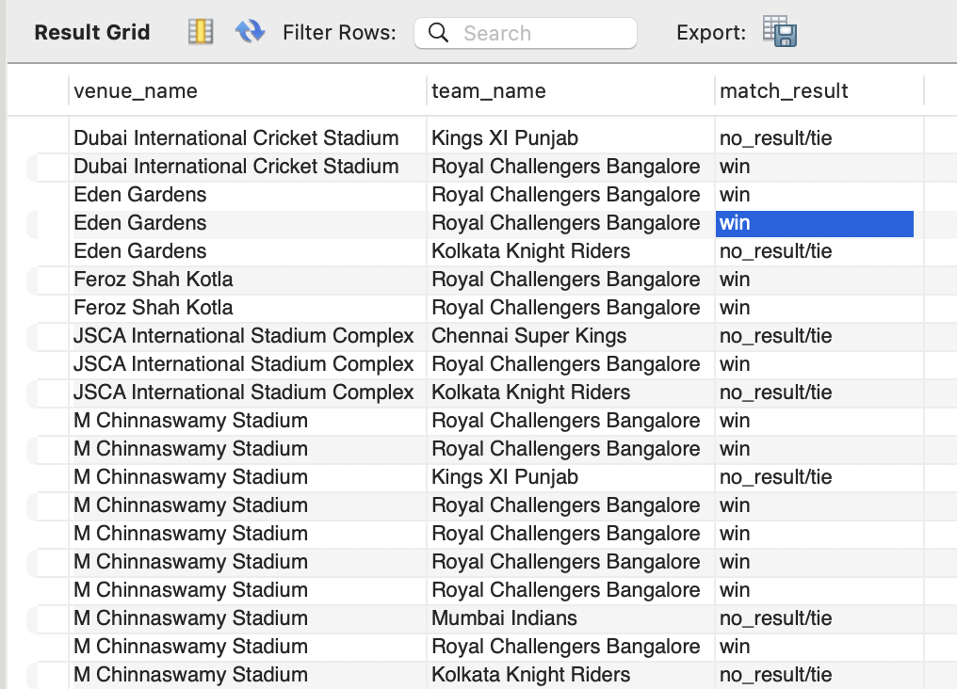
Explanation:
- Created a new table named rcb_record for rcb
- Merged three tables using JOIN
- Used a LEFT JOIN on the win_by table
- Used case statement to categorise the results as 'win' if the winner ID is 2, 'no_result/tie' if the outcome type is 1, and 'loss' for all other scenarios
- Where clause is used to Filter rcb played as either team_1 or team_2
- Sorted ascending order based on the venue_name column
- Used select * to display the created table

- What is the impact of bowling style on wickets taken?
Query :
select b.bowling_id,b.bowling_skill,o.out_name, row_number() over(partition by b.bowling_skill order by o.out_id) as rn
from bowling_style b
join wicket_taken w
on b.bowling_id = w.fielders
left join out_type o
on w.kind_out = o.out_id;
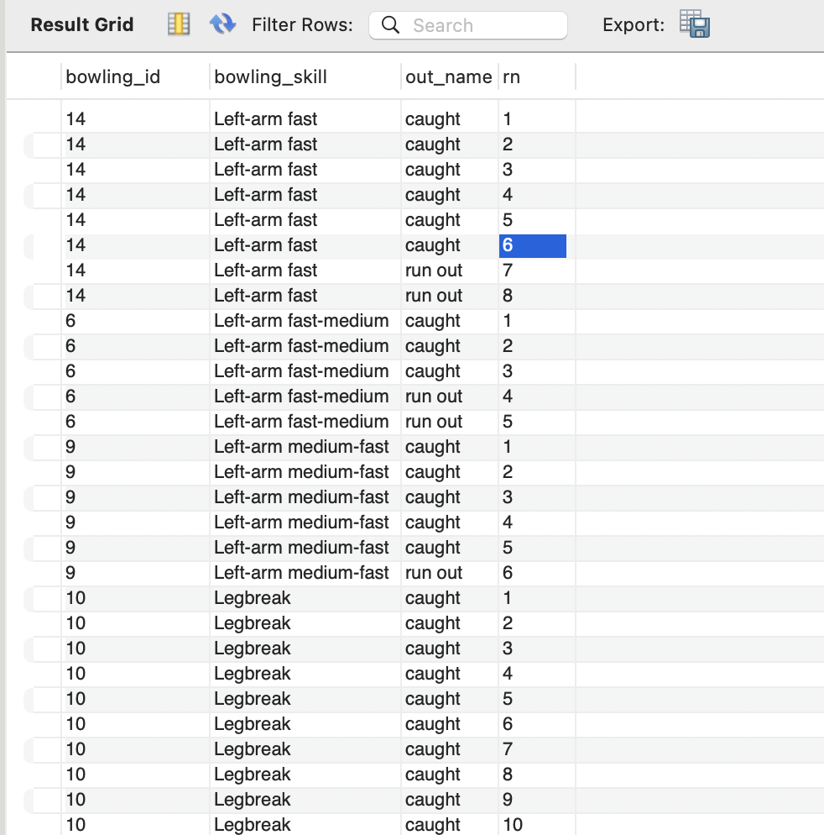
Explanation:
- Merged tables using a JOIN
- Used a Window Function to assign row numbers, Partitioned by b.bowling_skill, Ordered by o.out_id

- Write the SQL query to provide a status of whether the performance of the team is better than the previous year's performance on the basis of the number of runs scored by the team in the season and the number of wickets taken
Query :
with season_runs as (select m.season_id, b.team_batting as team_id,
sum(coalesce(b.runs_scored,0)+coalesce(r.extra_runs,0)) as total_runs
from ball_by_ball b
join matches m
on b.match_id= m.match_id
left join Extra_Runs r
on b.match_id = r.match_id
and b.innings_No=r.innings_No
and b.ball_Id =r.ball_Id
and b.over_Id = r.over_id
group by m.season_id,b.team_batting),

season_wickets as (select m.season_id,b.team_bowling as team_id,
count(w.player_out) as total_wickets
from ball_by_ball b
join matches m
on b.match_id = m.match_id
left join wicket_taken w
on b.match_id = w.match_id
and b.innings_No=w.innings_No
and b.ball_Id =w.ball_Id
and b.over_Id = w.over_id
group by m.season_id,b.team_bowling),

team_season as (select s.season_year, r.team_id,t.team_name,r.total_runs,
coalesce(w.total_wickets,0) as total_wickets
from season_runs r
left join season_wickets w on r.season_id=w.season_id and r.team_id=w.team_id
join season s on r.season_id = s.season_id
join team t on r.team_id = t.team_id),

performance as (select season_year, team_name,total_runs,total_wickets,
lag(total_runs)over(partition by team_id order by season_year) as prev_runs,
lag(total_wickets)over(partition by team_id order by season_year) as prev_wkt
from team_season)

select season_year, team_name, total_runs, total_wickets,
coalesce(cast(prev_runs as char),'N/A') as prev_year_runs,
coalesce(cast(prev_wkt as char),'N/A') as prev_year_wickets,
case
when prev_runs is null or prev_wkt is null then 'No data'
when total_runs> prev_runs and total_wickets>prev_wkt then 'Good'
else 'Poor'
end as performance_status
from performance
order by team_name, season_year;
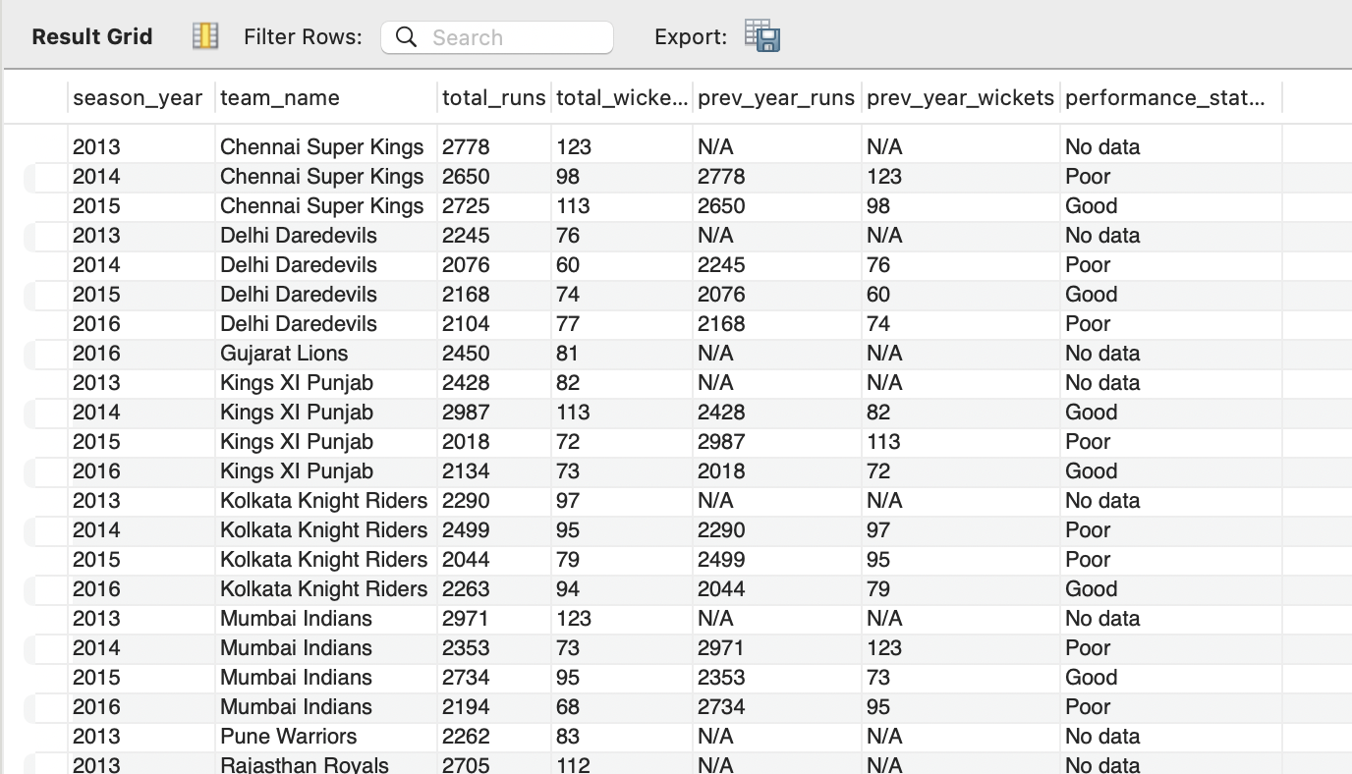
Explanation:
- Calculated runs scored in season_runs by combining batsman runs and extra runs for each team per season
- Calculated wickets taken in season_wickets by counting wickets for each bowling team per season
- Applied Window Functions to retrieve the previous season's total runs and wickets for each team
- Used case statement to categorize season's performance as 'Good', 'Poor' and 'No data'

- Can you derive more KPIs for the team strategy?
- Batting and bowling style need to be analysed to understand how it affect the performance
- Geographical analysis of the pitch and understanding the impact of weather
- Analysing how the speed of bowling affects the performance
13. Using SQL, write a query to find out the average wickets taken by each bowler in each venue. Also, rank the gender according to the average value.
Query :
select p.player_name as bowler_name,v.venue_name,
count(w.player_out) as total_wickets_taken,
count(distinct b.match_id) as total_matches_bowled,
round(count(w.player_out)*1.0/count(distinct b.match_id),2)as avg_wickets_per_match
from ball_by_ball b
join matches m
on b.match_id=m.match_id
join venue v on m.venue_id = v.venue_id
join player p on b.bowler = p.player_id
left join wicket_taken w
on b.match_id = w.match_id
and b.over_id = w.over_id
and b.ball_id = w.ball_id
and b.innings_no = w.innings_no
and w.kind_out not in (3,5,9)
group by p.player_id,p.player_name,v.venue_id,v.venue_name
order by avg_wickets_per_match desc;
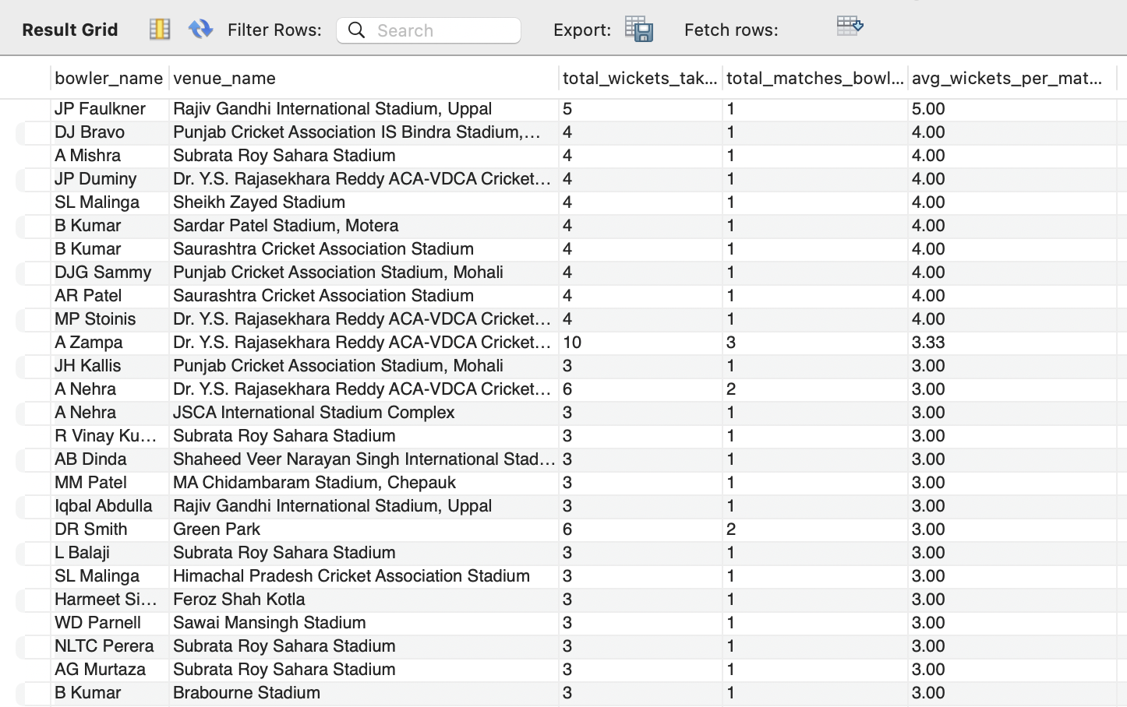
Explanation:
- Selected columns player_name (as bowler_name), venue_name, and calculated counts for total wickets, unique matches, and the average of wickets taken per match
- Merged four tables using join
- Filtered out non-bowler wickets inside the join condition using w.kind_out not in (3,5,9)
- Grouped by player_id, player_name, venue_id, and venue_name
- Ordered by descending order

13. Which of the given players have consistently performed well in past seasons? (will you use any visualization to solve the problem)
Query:
select p.player_name, sum(b.runs_scored) as total_runs, s.season_year, count(ball_id) as ball_cnt
from ball_by_ball b
left join matches m
on b.match_id = m.match_id
left join season s
on m.season_id = s.season_id
left join player p
on p.player_id = b.striker
group by b.striker, s.season_year;

-- bowler performance table
select p.player_name as bowler_name, sum(b.runs_scored) as striker_runs, count(w.player_out) as wicket_cnt, count(b.ball_id) as ball_cnt,
s.season_year
from ball_by_ball b
join matches m
on b.match_id = m.match_id
join season s
on m.season_id = s.season_id
join player p
on p.player_id = b.bowler
left join wicket_taken w
on b.match_id = w.match_id
and b.over_id = w.over_id
and b.ball_id = w.ball_id
and b.innings_no = w.innings_no
group by p.player_name, s.season_year;
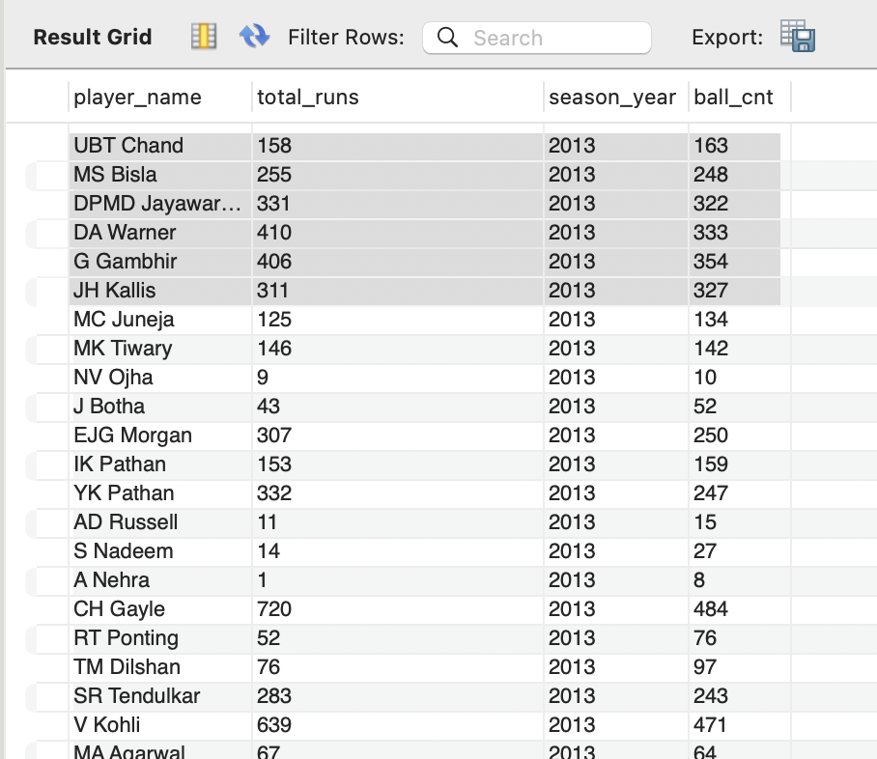
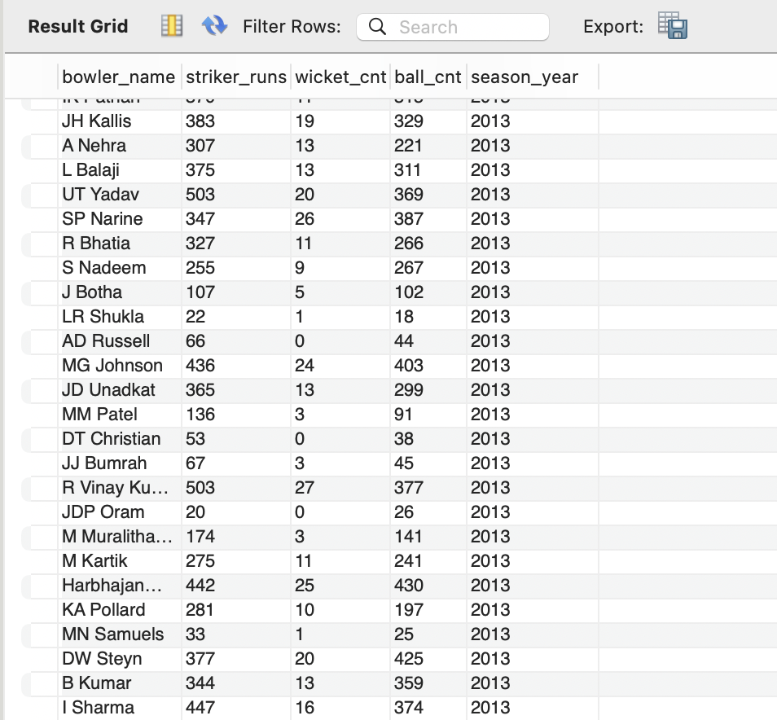

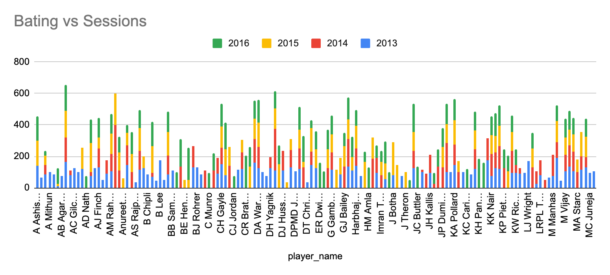
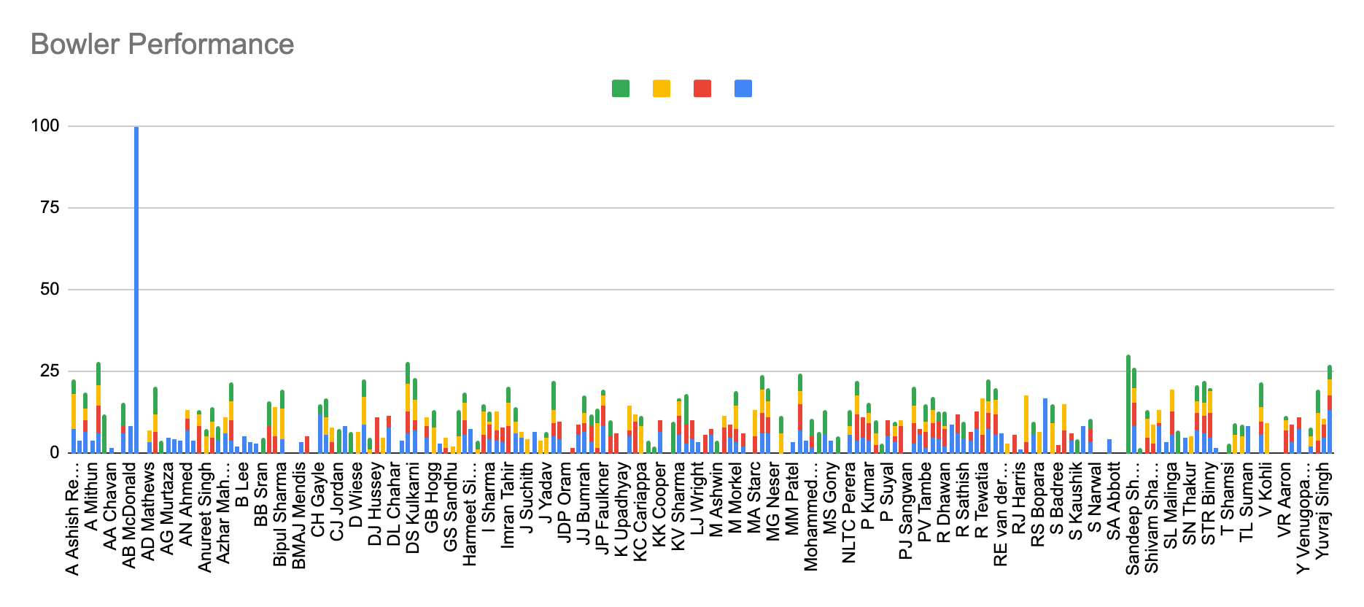
Approach:
- Batsman and bowler performance of each season are analysed separately.
- Calculated total runs taken by each batsman and ball count by joining ball_by_ball, matches, season and player table. And grouped by season and striker
Used Excel formula to calculate total runs/ball count for each player
Created stacked chart to visualize the performance
- Calculated total wickets taken by each bowler and ball count by joining ball_by_ball, matches, season, player, wickets taken table. And grouped by season and bowler
Used Excel formula to calculate total wickets taken/ball count for each player
Created stacked chart to visualize the performance
Insights:
By analysing the batting and bowling performance,
- AB de villiers, AJ Flinch, AT Rayudu, CH Gayle, DJ Bravo, G. Gambhir, Maxwell, Harbhajan Singh kept consistency in batting
- A Nehra, B Kumar, DR Smith, MG Johnson, RA Jadeja,Sandeep Sharma and Z Khan kept consistency in bowling
14. Are there players whose performance is more suited to specific venues or conditions? (how would you present this using charts?)
Code:
select p.player_name, sum(b.runs_scored) as total_runs, v.venue_id, count(ball_id) as ball_cnt
from ball_by_ball b
left join matches m
on b.match_id = m.match_id
left join venue v
on m.venue_id = v.venue_id
left join player p
on p.player_id = b.striker
group by b.striker, v.venue_id;

-- bowler performance table
select p.player_name as bowler_name, sum(b.runs_scored) as striker_runs, count(w.player_out) as wicket_cnt, count(b.ball_id) as ball_cnt,
v.venue_id
from ball_by_ball b
join matches m
on b.match_id = m.match_id
join venue v
on m.venue_id = v.venue_id
join player p
on p.player_id = b.bowler
left join wicket_taken w
on b.match_id = w.match_id
and b.over_id = w.over_id
and b.ball_id = w.ball_id
and b.innings_no = w.innings_no
group by p.player_name, v.venue_id;
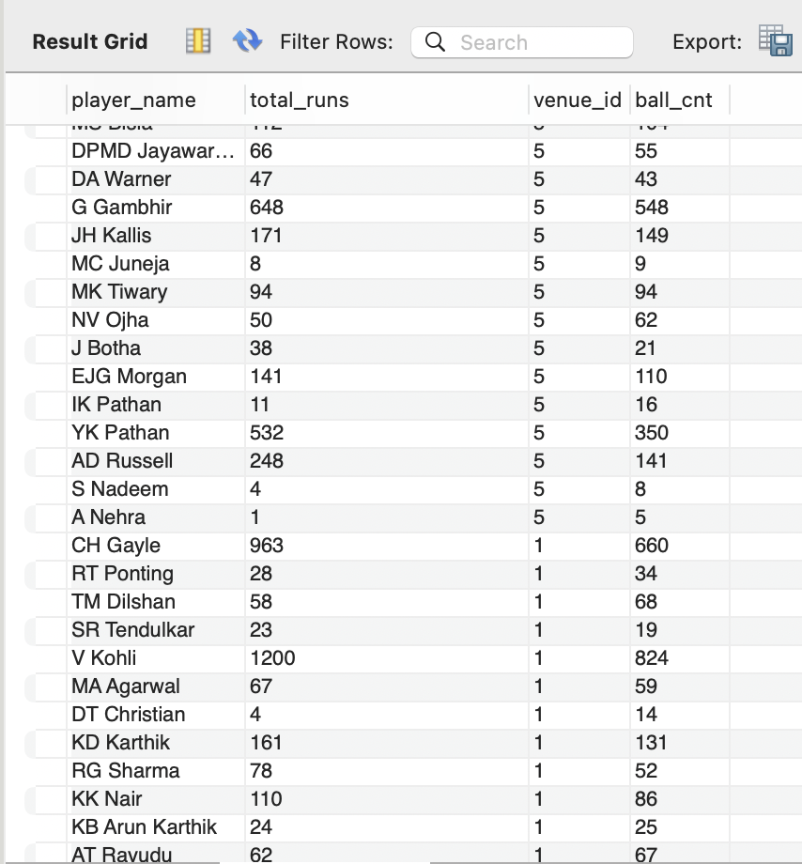
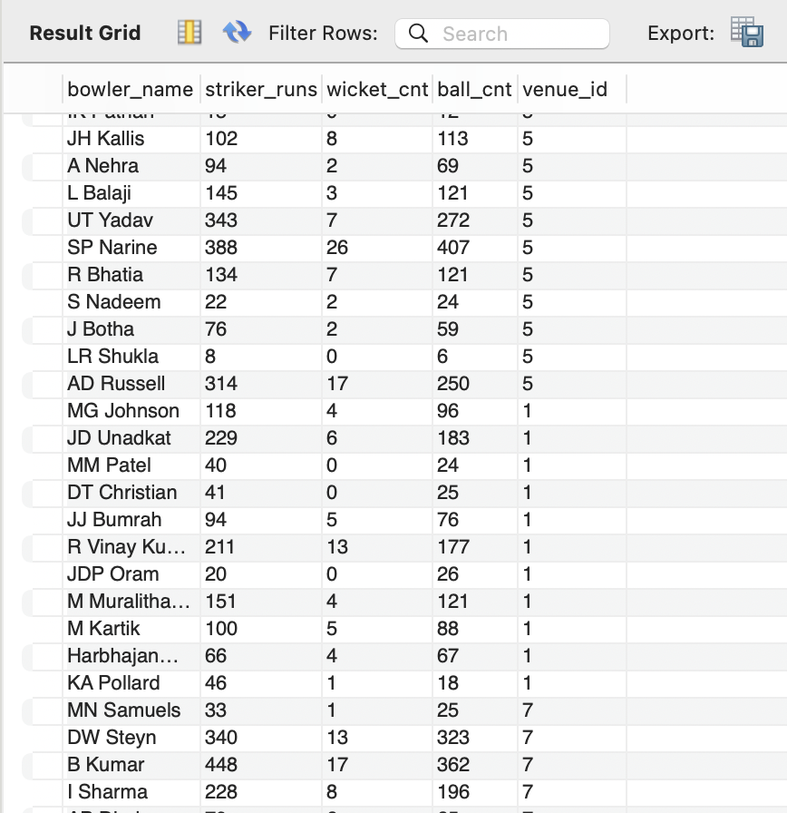
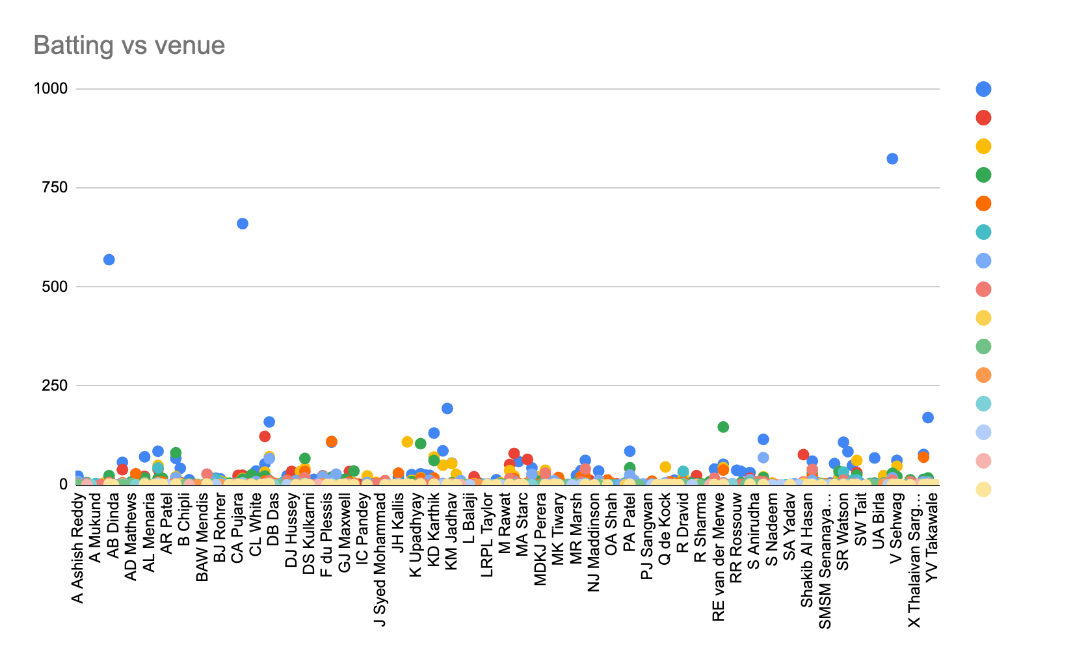
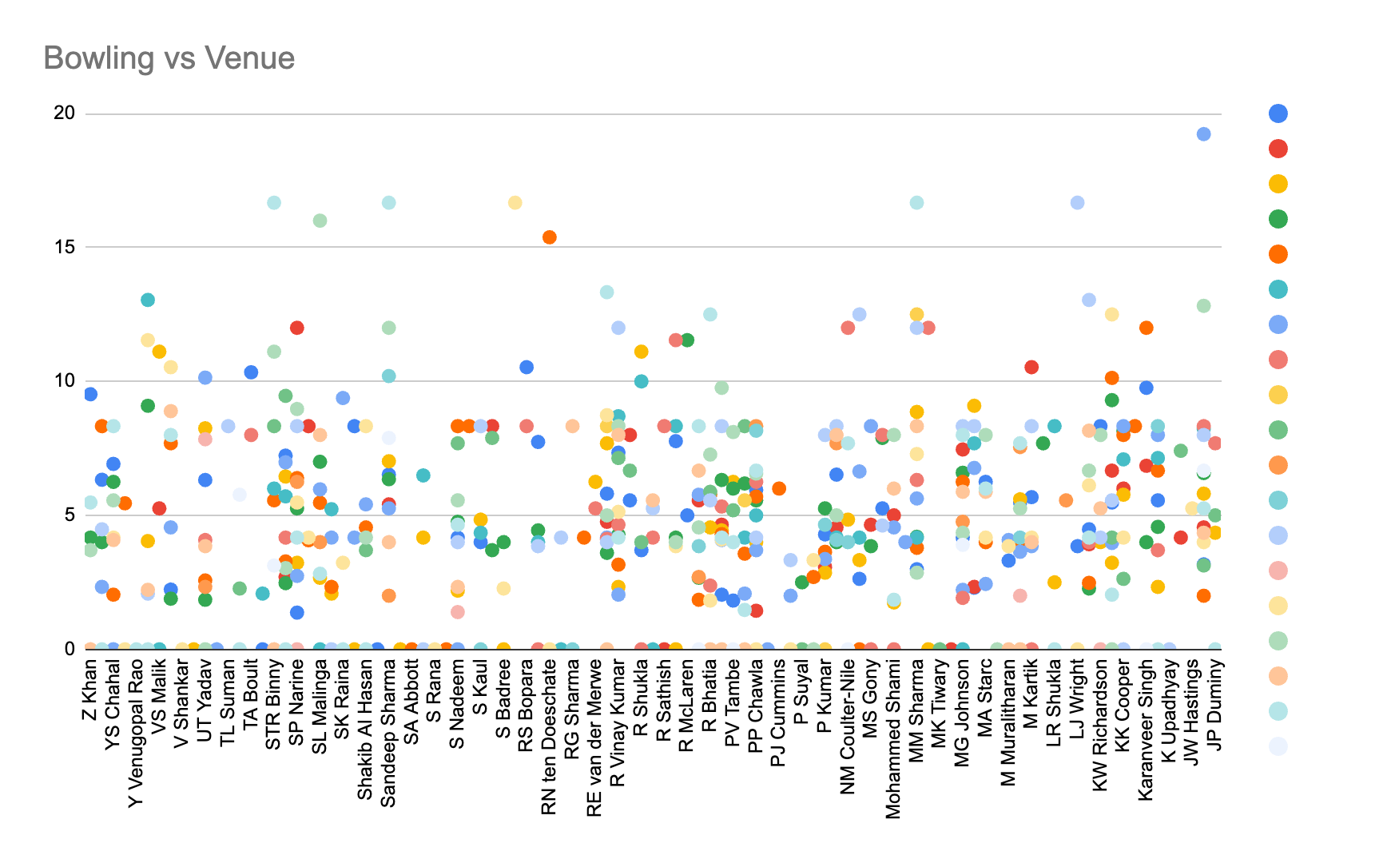

Approach :
- Batsman and bowler performance are analysed seperately.
- Calculated total runs taken by each batsman and ball count by joining ball_by_ball, matches, venue and player table. And grouped by venue and striker to find the total runs taken by batsman on each venue.
- Used Excel formula to calculate total runs/ball count for each player
- Created scattered chart to visualize the performance
- Calculated total wickets taken by each bowler and ball count by joining ball_by_ball, matches, venue, player, wickets taken table. And grouped by venue and bowler
- Used Excel formula to calculate total wickets taken/ball count for each player
- Created scattered chart to visualize the performance of each venue
Insights
- Yes, players have shown outstanding performance in certain venues.
- Venue 1, 2 and 3 are seen ideal for batting
- Venue 31 and 26 are ideal for bowling
Recommendation
- Study on the climate, geography and other external factors of the venue and give training and preparations

Subjective Questions

- How does the toss decision affect the result of the match? (which visualizations could be used to present your answer better) And is the impact limited to only specific venues?
Query
select p.player_name, sum(b.runs_scored) as total_runs, v.venue_id, count(ball_id) as ball_cnt
from ball_by_ball b
left join matches m
on b.match_id = m.match_id
left join venue v
on m.venue_id = v.venue_id
left join player p
on p.player_id = b.striker
group by b.striker, v.venue_id;
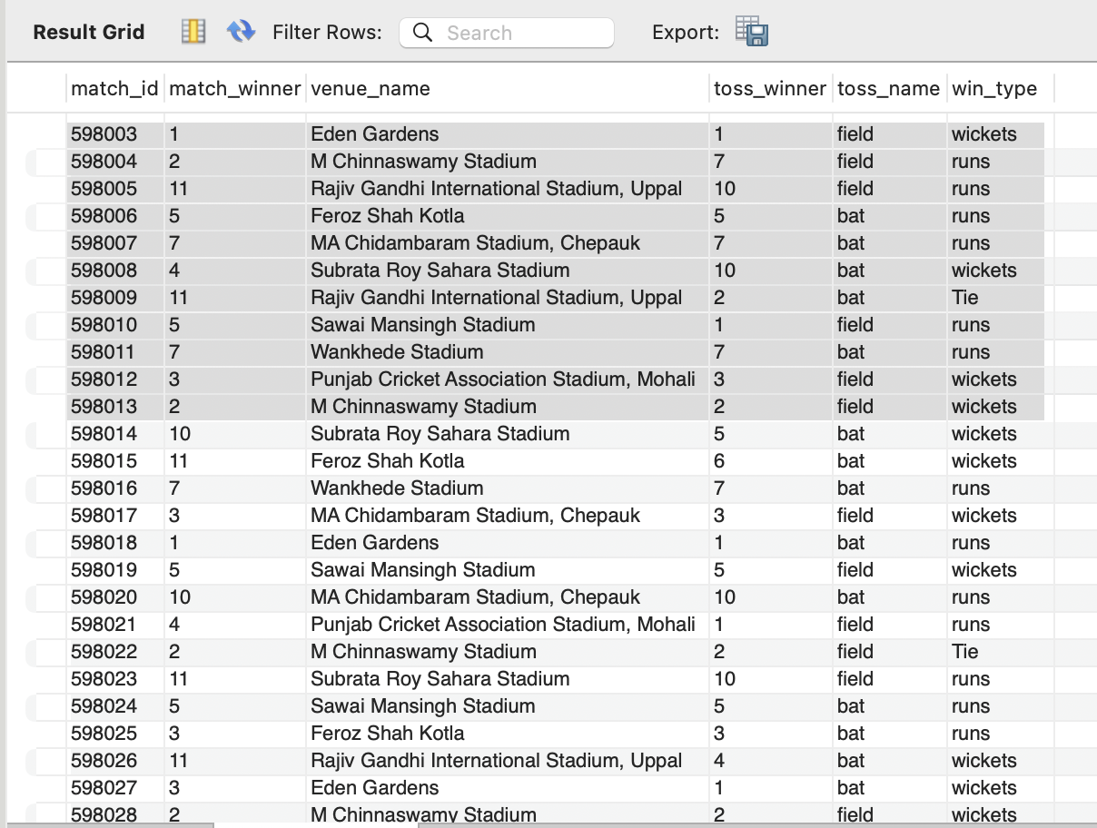

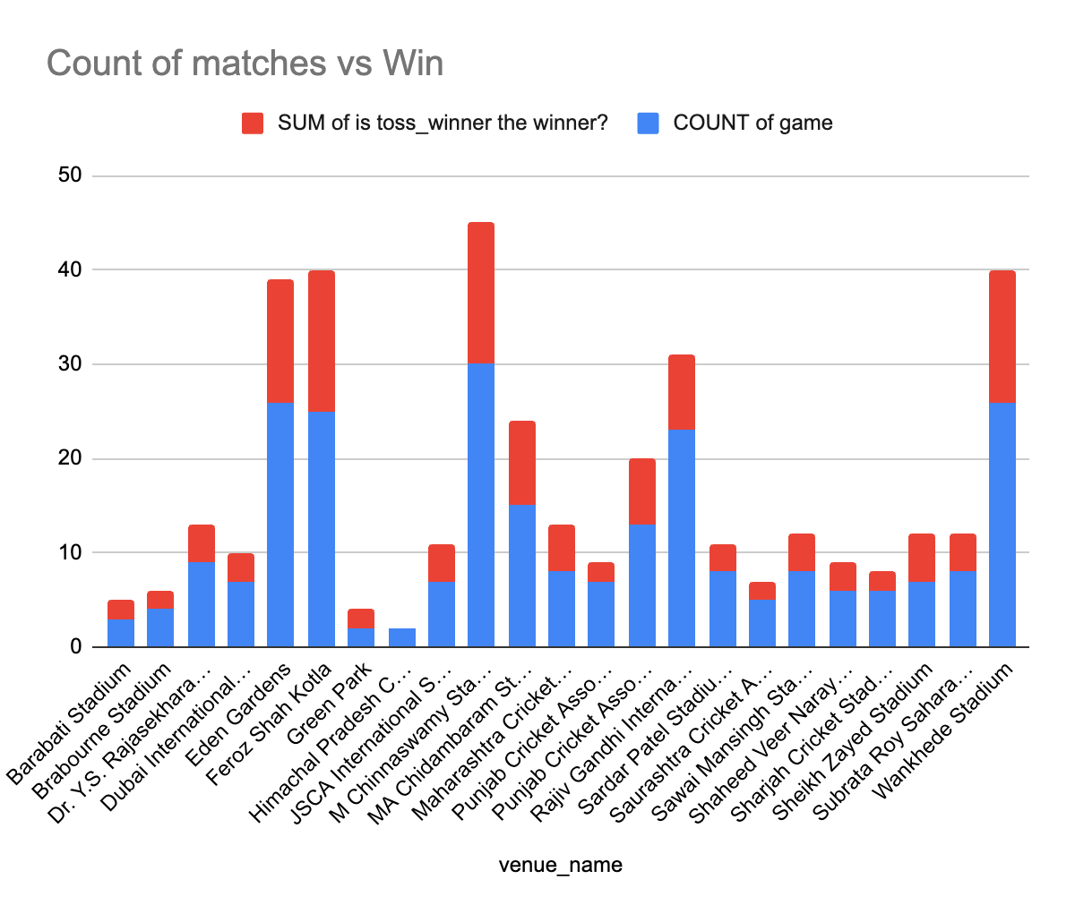
Approach:
- Retrieved total runs scored and the ball count of each player for each venue by joining tables and grouping them by player and venue
- Used excel IF to analyse is the toss winner actual winner of the game
- Used excel to sum game count and winning team count for each venue and plotted on stacked chart
Insights
- We cannot say toss decisions affect the match result because the number of times toss winners are winning the matches are very less.
- Suggest some of the players who would be best fit for the team.
Query;
select p.player_name, sum(b.runs_scored) as total_runs
from ball_by_ball b
join player p
on b.striker = p.player_id
group by b.striker
order by total_runs desc
limit 10;
Approach
- Used joins to merge the bal_by_ball table and player table
- Grouped by striker and found total runs using sum()
- Order the column descending order
- Used limit to get the top 10 players according to the highest total runs
Recommendation:
- Study on Players physique, batting speed and style and incorporate in the training
- What are some of the parameters that should be focused on while selecting the players?
- Check whether the player is all-rounder
- Check their consistency in the past performances
- Age and Past Injuries

- Which players offer versatility in their skills and can contribute effectively with both bat and ball? (can you visualize the data for the same)
Query:
with player_batting as(select b.striker as player_id,
sum(coalesce(b.runs_scored, 0)) as total_runs,
count(distinct b.match_id) as matches_played,
sum(coalesce(b.runs_scored, 0)) * 1.0 / count(distinct b.match_id) as avg_runs
from ball_by_ball b
group by b.striker),

player_bowling as (select b.bowler as player_id,
count(w.player_out) as total_wickets
from ball_by_ball b
left join wicket_taken w
on b.match_id = w.match_id
and b.innings_no = w.innings_no
and b.over_id = w.over_id
and b.ball_id = w.ball_id
and w.kind_out not in (3, 5, 9)
group by b.bowler),

overall_metrics as (select (select avg(avg_runs) from player_batting) as global_avg_runs,
(select avg(total_wickets) from player_bowling) as global_avg_wickets)

select p.player_name,
round(bat.avg_runs, 2) as player_avg_runs,
round(om.global_avg_runs, 2) as benchmark_avg_runs,
bowl.total_wickets as player_total_wickets,
round(om.global_avg_wickets, 2) as benchmark_wickets
from player_batting bat
join player_bowling bowl on bat.player_id = bowl.player_id
join player p on bat.player_id = p.player_id
cross join overall_metrics om
where bat.avg_runs > om.global_avg_runs
and bowl.total_wickets > om.global_avg_wickets
order by bat.avg_runs desc, bowl.total_wickets desc;

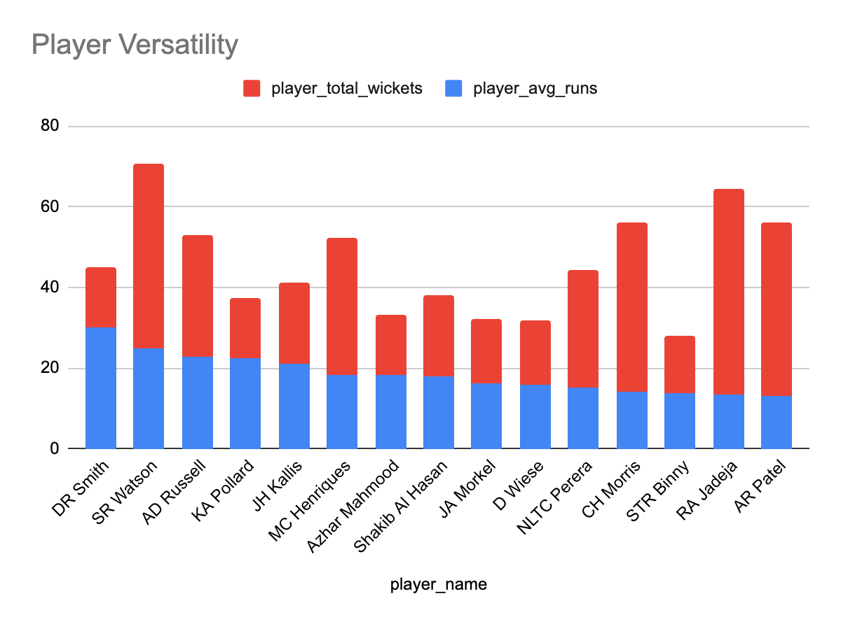
Approach:

- Calculated batting data in player_batting by grouping by b.striker to find total_runs, matches_played, and the average runs scored per match
- Aggregated bowling data in player_bowling by grouping by b.bowler and used a left join with wicket_taken to count total wickets while filtering out non-bowler wickets using kind_out not in (3, 5, 9)
- Calculated global benchmarks in overall_metrics by finding the average of runs and wickets across all players in the database
- Merged all tables using JOIN
- Filtered for all-rounders using a where clause to filter players whose individual batting averages and total wickets are higher than the global averages
- Rounded to two decimal places, sorted in descending order to prioritise the top-performing batsmen and bowlers

- Are there players whose presence positively influences the morale and performance of the team? (justify your answer using visualization)
Query:
-- player win count
select p.player_id, pl.player_name, p.team_id, count(m.match_id) as total_matches,
sum(case when p.team_id = m.match_winner then 1 else 0 end) as win_cnt
from Matches m
join player_match p
on p.match_id = m.match_id
join player pl
on pl.player_id = p.player_id
group by p.player_id, p.team_id, pl.player_name;
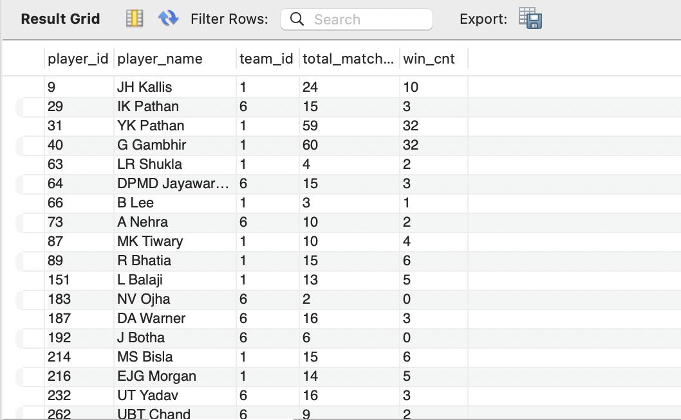
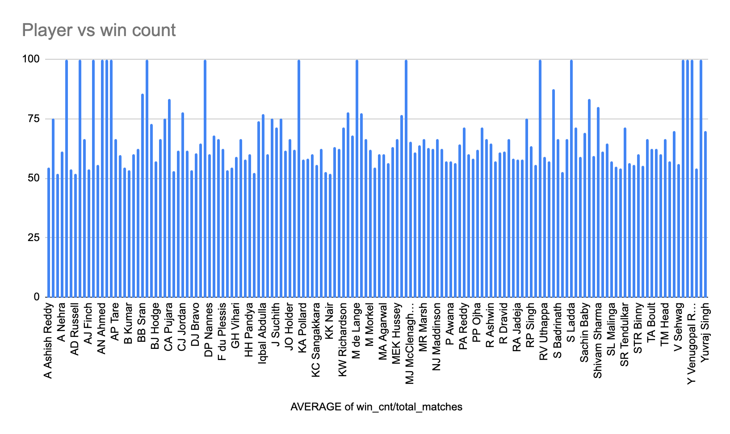

Approach
- Calculated total matches played by the player and count of winning matches
- Calculated win rate from win count and total matches played by the players
- Used a column chart to analyse
Insight
- Players with a win rate more than 75 would positively influence the team's performance.
Recommendation:
- It is good to have a lucky charm in the team but it is better to focus on real performance than the luck factors.
- Give less effort to onboard player with luck factor, consider hiring outstanding players

- What would you suggest to RCB before going to the mega auction?
- Consider players with good performance preferably all rounders
- Players who perform well irrespective of any venue or condition

- What do you think could be the factors contributing to the high-scoring matches and the impact on viewership and team strategies
- Aggressive training and mental preparations to adapt all conditions
- Proper understanding about the pitch
- Understanding about the opponents - their strength and weakness
- Analyze the impact of home-ground advantage on team performance and identify strategies to maximize this advantage for RCB.
Query
select venue_name, team_name,
sum(case when match_result ='win' then 1 else 0 end) as wins,
sum(case when match_result = 'no_result/tie' then 1 else 0 end) as tie,
sum(case when match_result = 'loss' then 1 else 0 end) as losses
from rcb_record
where team_name = 'Royal Challengers Bangalore'
group by venue_name, team_name;
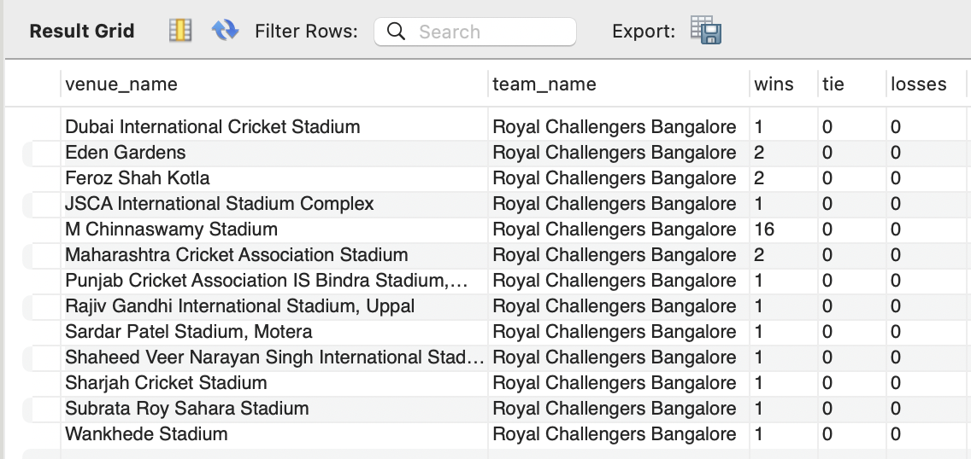
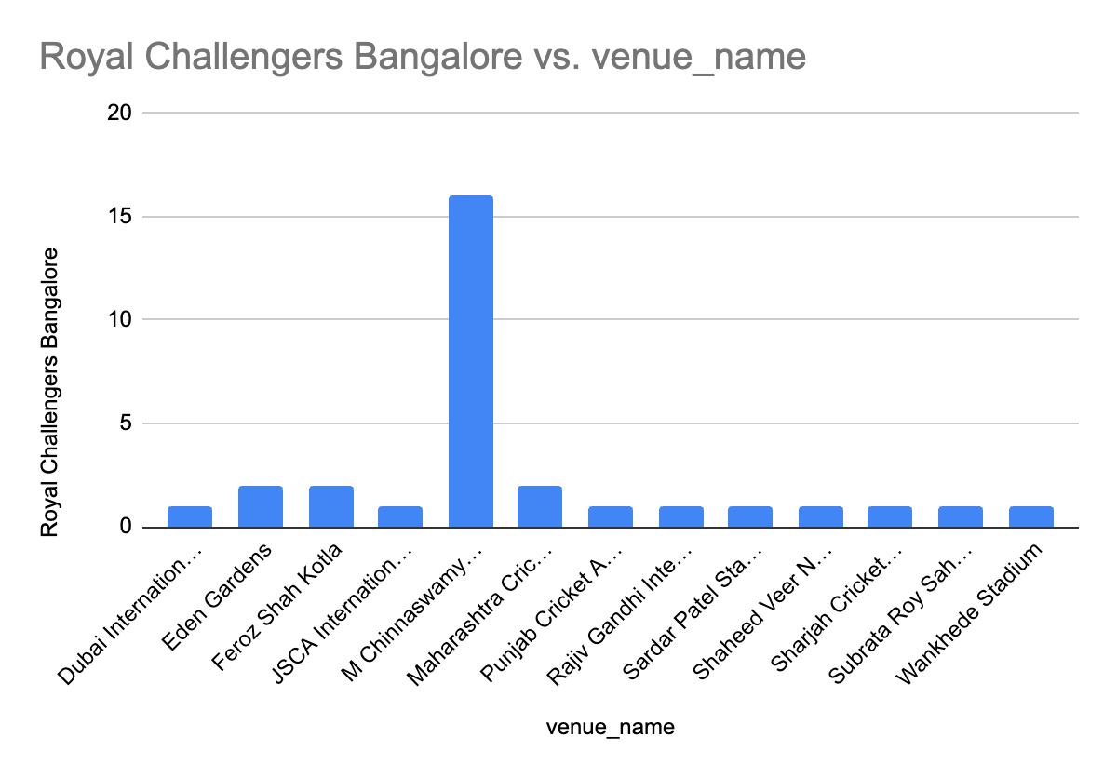

Approach:
- Used case statement to count win and loss of rcb at each venue.
- Applied column chart to analyse the team’s performance at different venue

Recommendation
- Home ground has huge impact on the performance
- Strategies that are included are travel 1 week prior to the match to get accommodated with the match location.
- Practice in different grounds/pitches

- Come up with a visual and analytical analysis of the RCB's past season's performance and potential reasons for them not winning a trophy.
Query: -- match wise performance
with rcb_runs as (select m.match_id, t.team_id, t.team_name, sum(coalesce(b.runs_scored,0) + coalesce(e.extra_runs,0)) as total_runs, v.venue_name, m.toss_winner, s.season_year, s.season_id
from ball_by_ball b
left join extra_runs e
on b.match_id = e.match_id
and b.over_id = e.over_id
and b.ball_id = e.ball_id
and b.innings_no = e.innings_no
left join team t
on b.team_batting = t.team_id
left join matches m
on b.match_id = m.match_id
left join season s
on m.season_id = s.season_id
left join venue v
on m.venue_id = v.venue_id
where lower(t.team_name) in ('rcb', 'royal challengers bangalore', 'Royal Challengers Bengaluru')
group by m.match_id,t.team_id, t.team_name, s.season_year, v.venue_name, m.toss_winner,s.season_id),

rcb_wickets as (select b.match_id, m.season_id,b.team_bowling as team_id,
count(w.player_out) as total_wickets
from ball_by_ball b
join matches m
on b.match_id = m.match_id
left join wicket_taken w
on b.match_id = w.match_id
and b.innings_No=w.innings_No
and b.ball_Id =w.ball_Id
and b.over_Id = w.over_id
where b.team_bowling =2
group by b.match_id,m.season_id,b.team_bowling)

select r.match_id, r.season_year,r.team_name,r.total_runs, coalesce(w.total_wickets,0) as total_wickets, r.venue_name, r.toss_winner, mt.match_winner
from rcb_runs r
left join rcb_wickets w on r.season_id = w.season_id and r.team_id=w.team_id and r.match_id= w.match_id
left join matches mt
on r.match_id = mt.match_id;
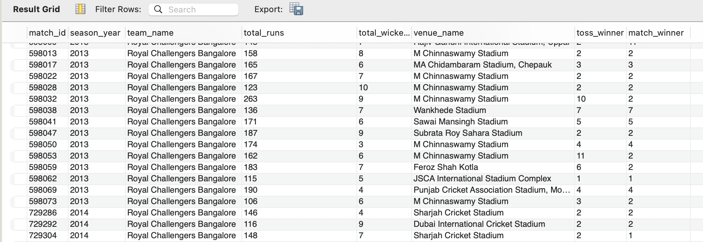
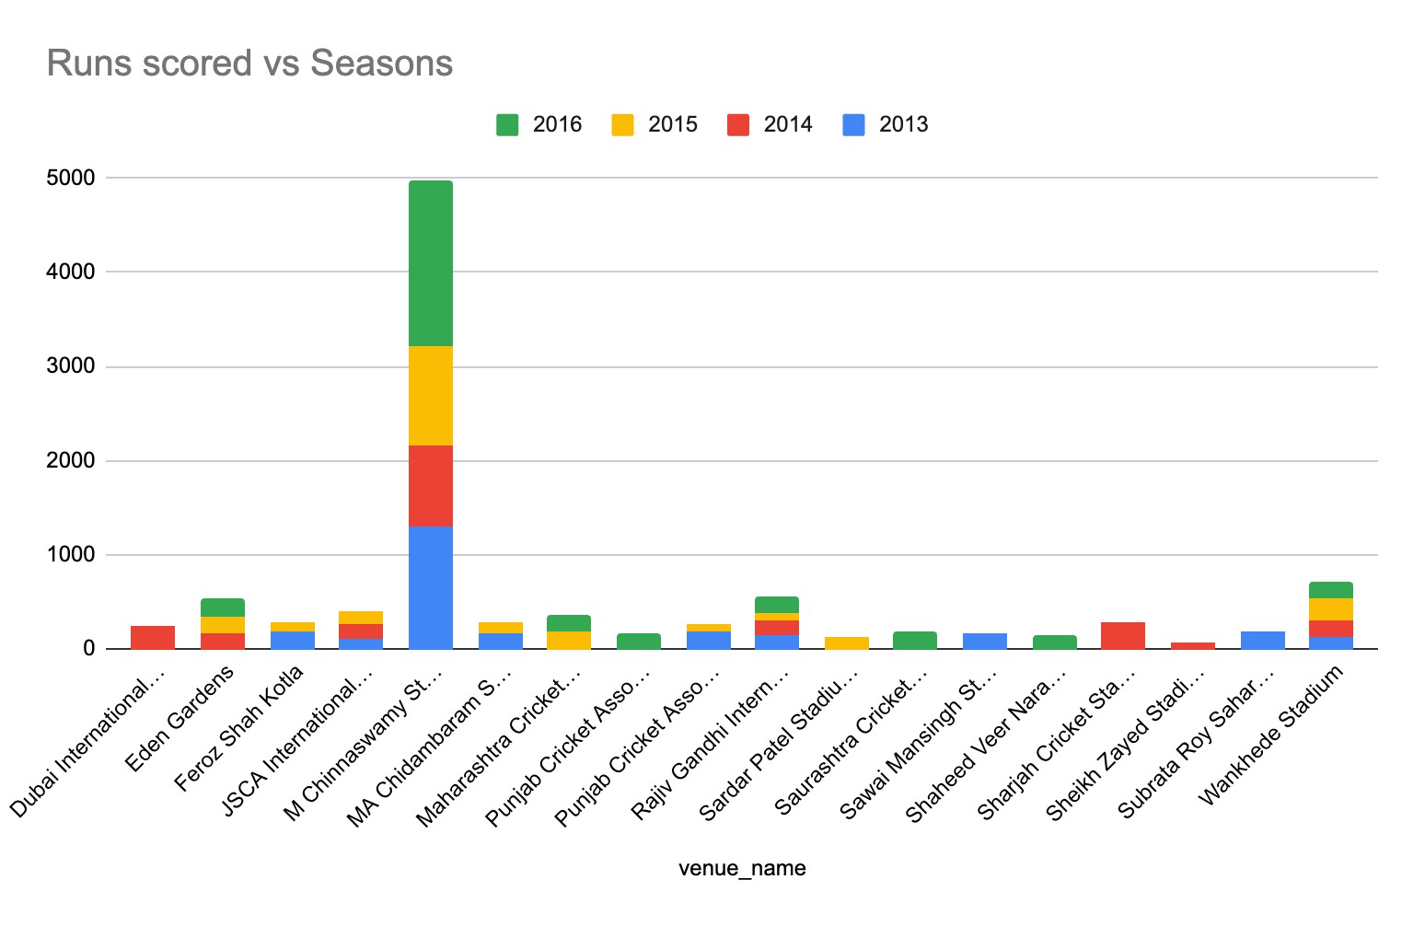
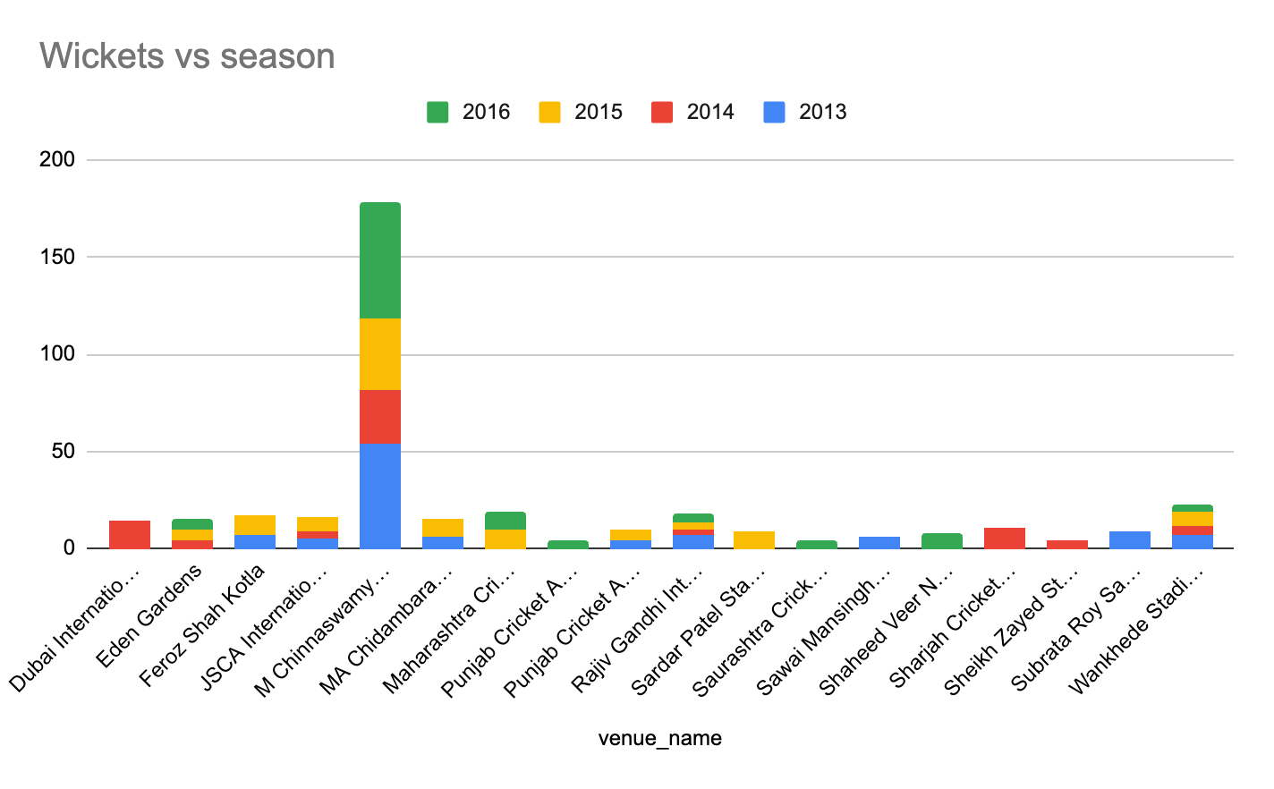
Approach
- Calculates the total runs scored by RCB in every match they have played.
- Calculates the total wickets taken by RCB's bowlers in each match.
- Used stacked chart to analyse player performance against season and venue
Insights:
- The chart shows that throughout of the season, players performance on the home land is consistent and outstanding
- Venue is the reason that rcb didn't win the match

- How would you approach this problem, if the objective and subjective questions weren't given?
- Analyse the player performance, age and batting/bowling style
- Analyse impact of venue and toss decision

- In the "Match" table, some entries in the "Opponent_Team" column are incorrectly spelled as "Delhi_Capitals" instead of "Delhi_Daredevils". Write an SQL query to replace all occurrences of "Delhi_Capitals" with "Delhi_Daredevils".
No matches table

